Q1

Q.2

Q.3

Q4

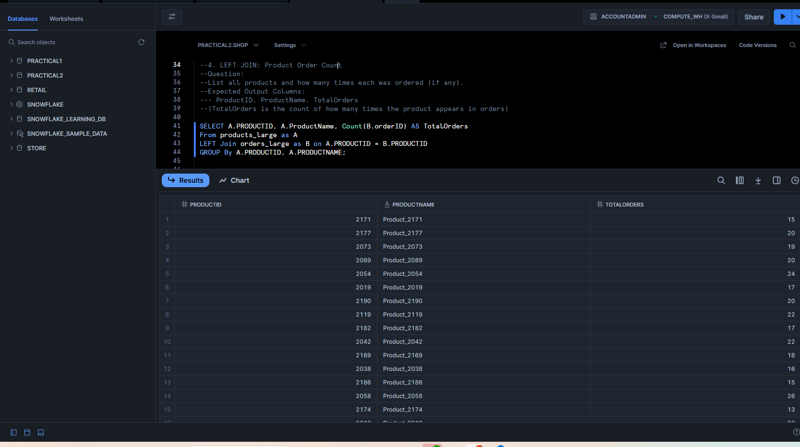

Q5

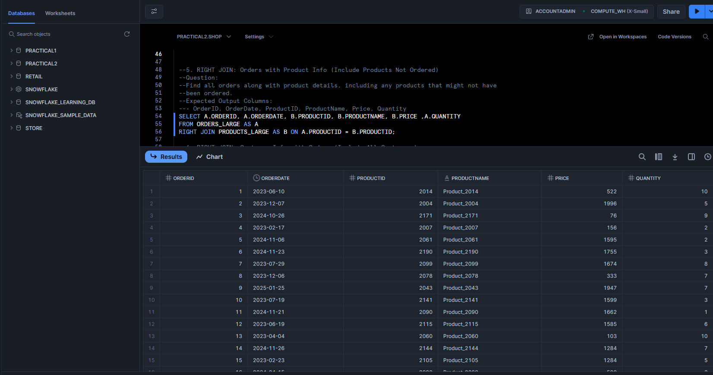

Q6

Q7

Q8

